Result Analysis

Dataset Characteristics and Class Distribution:
From two independent glioma cohorts the study utilized mutation and clinical data. Training and testing was conducted on TCGA dataset that contains 839 patients and the CGGA dataset which contains 286 patients was used only for external validation to evaluate cross-cohort generalization. The TCGA shows a mild class imbalance with 487 LGG[Grade 0] (58%) and 352 GBM[Grade 1], which shows an imbalance ratio of approximately 1.38:1. A test set of 168 patients (98 Grade-0 and 70 Grade 1) was held out and never used during model training. The CGGA cohort has bit stronger imbalance with 64% Grade-0 and 36% Grade-1 samples.
Interpretation: The observation of mild imbalance indicates that advance resampling strategies are not strictly required for numerical stability. This is later confirmed in the pipeline comparison experiments where baseline performance remains robust.
Comparative Model Performance:
A comparative evaluation of seven heterogeneous graph neural network (HGNN) architecture was conducted using four different data balancing pipelines. The result shows a clear two-tier performance structure. MOGAT, FastHGTConv and HeteroGATv2 consistently outperformed the remaining architectures by approximately 0.07 - 0.10 AUC across all test scenarios.
Among these, the MOGAT model combined with random oversampling(ROS) achieves the highest predictive performance, reaching the AUC of 0.923 on TCGA test set and 0.809 on the independent CGGA cohort.

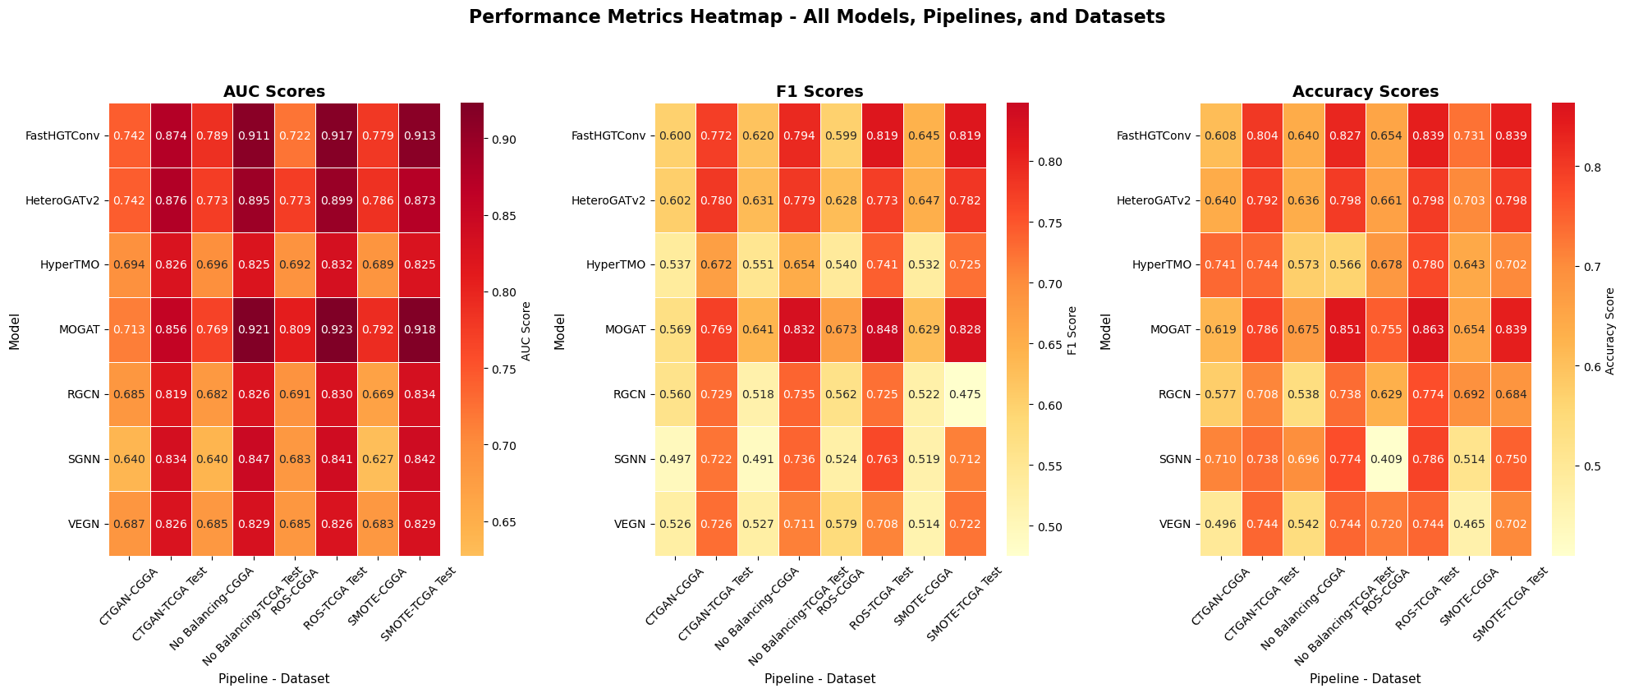
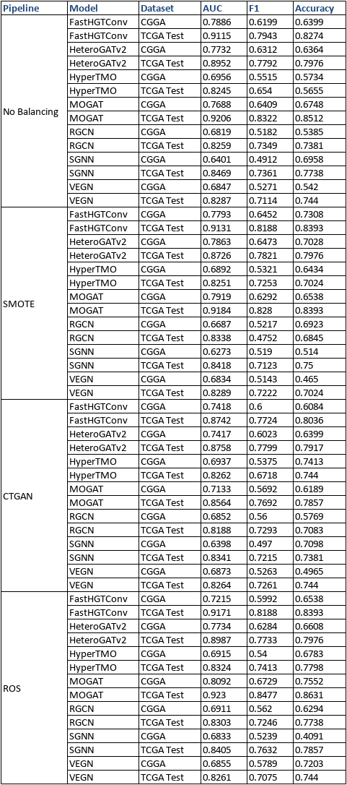
Table 1 - AUC, F1-Score and Accuracy for all 7 models

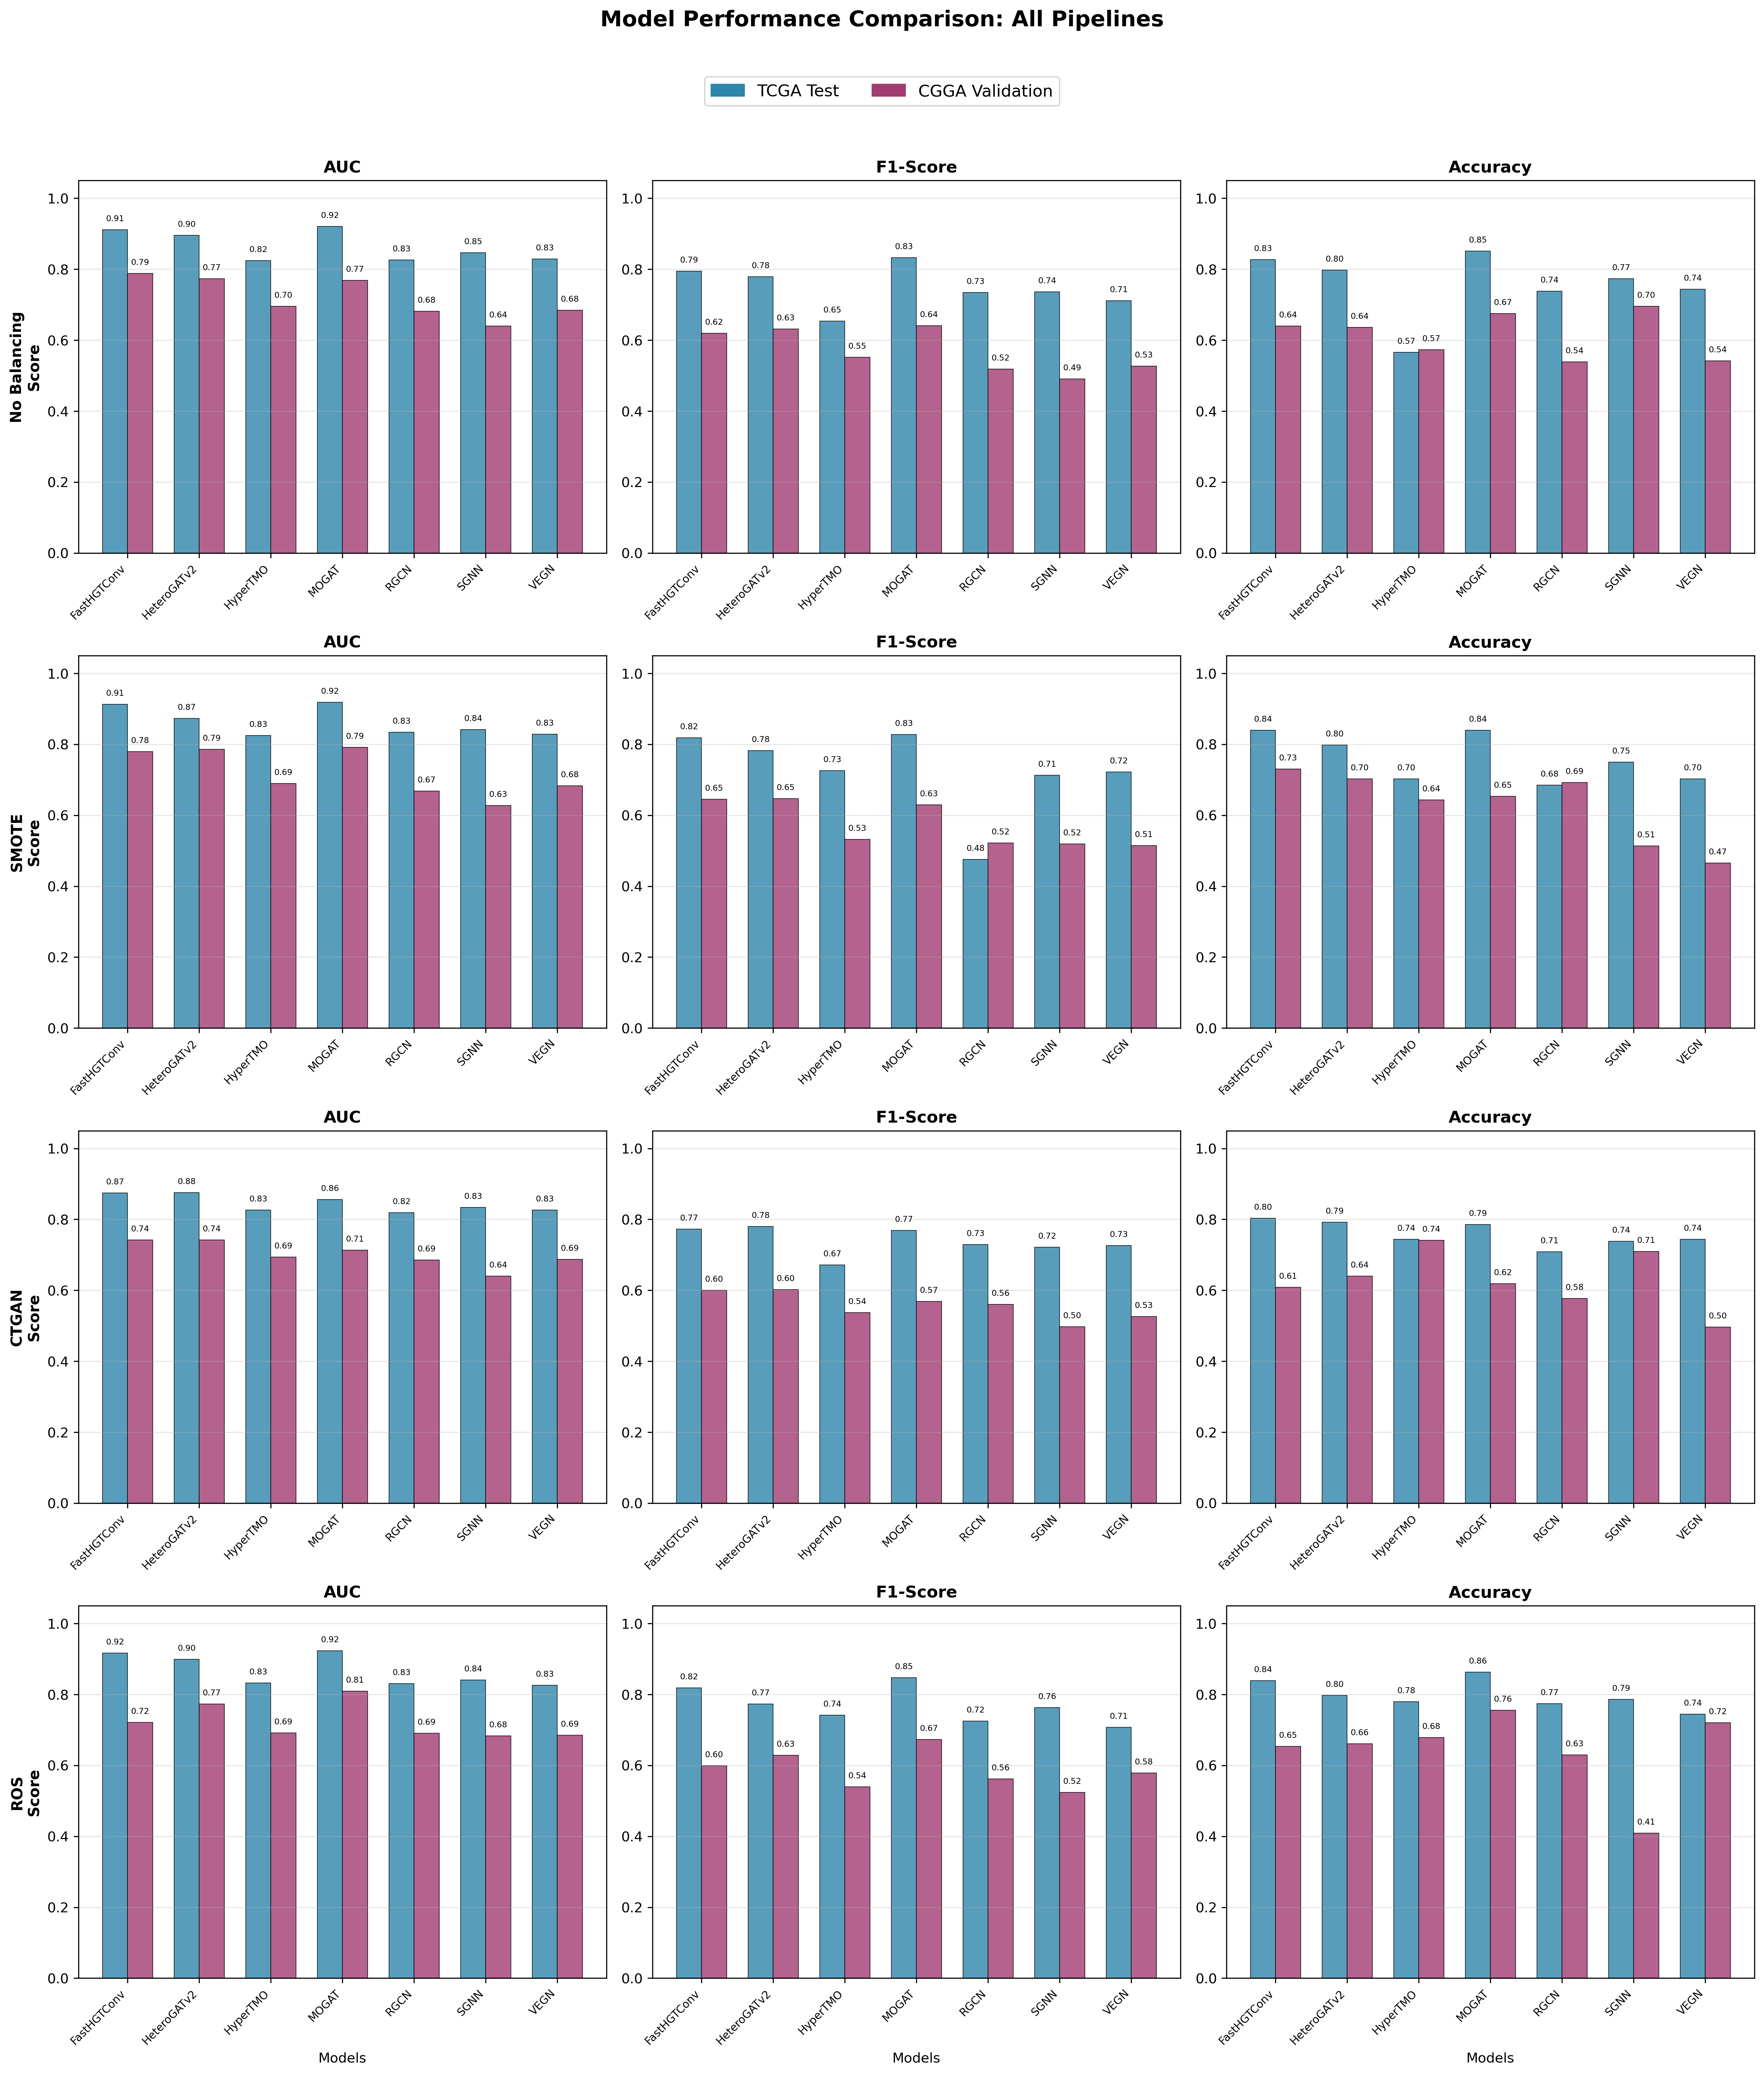

Effect of Class Balancing Strategies
Four balancing strategies were evaluated: No Balancing, SMOTE, CTGAN and Random Over Sampling (ROS). The average AUC across all models shows that ROS achieves the highest overall performance (mean TCGA AUC = 0.876), closely followed by the baseline without balancing (0.870).
While SMOTE provides only marginal improvement, CTGAN consistently underperforms across all architectures. These finding suggest the mild class imbalance present in the dataset is properly handled by focal loss and class weighting mechanisms used during training.
Interpretation: The underperformance of CTGAN suggests that synthetic mutation generation may disrupt the true co-mutation structure and biological constraints inherent in real world genomics networks.

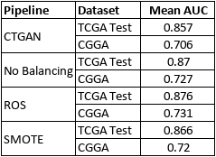
Table 2 - Mean AUC grouped by balancing pipeline

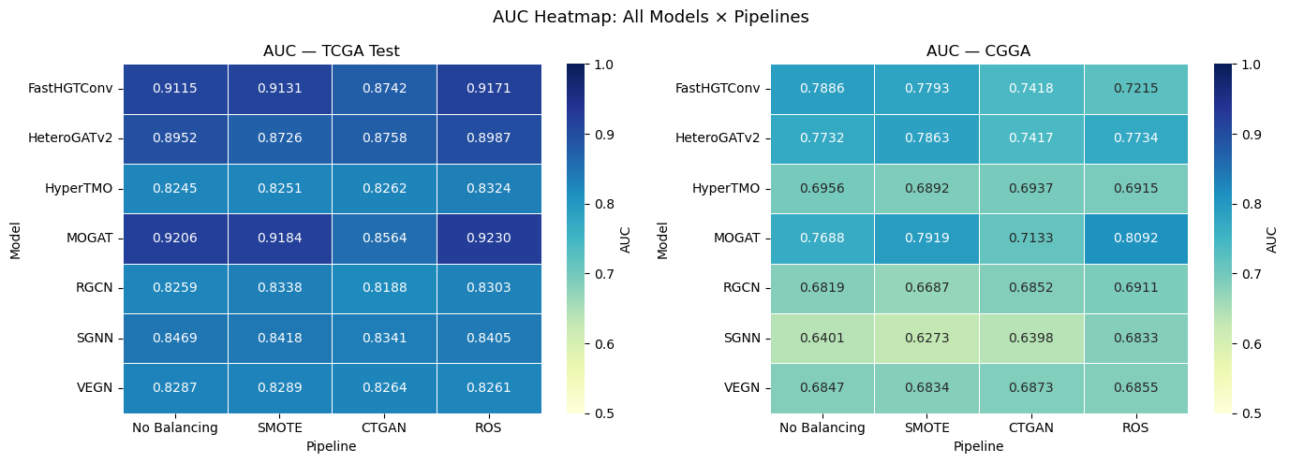
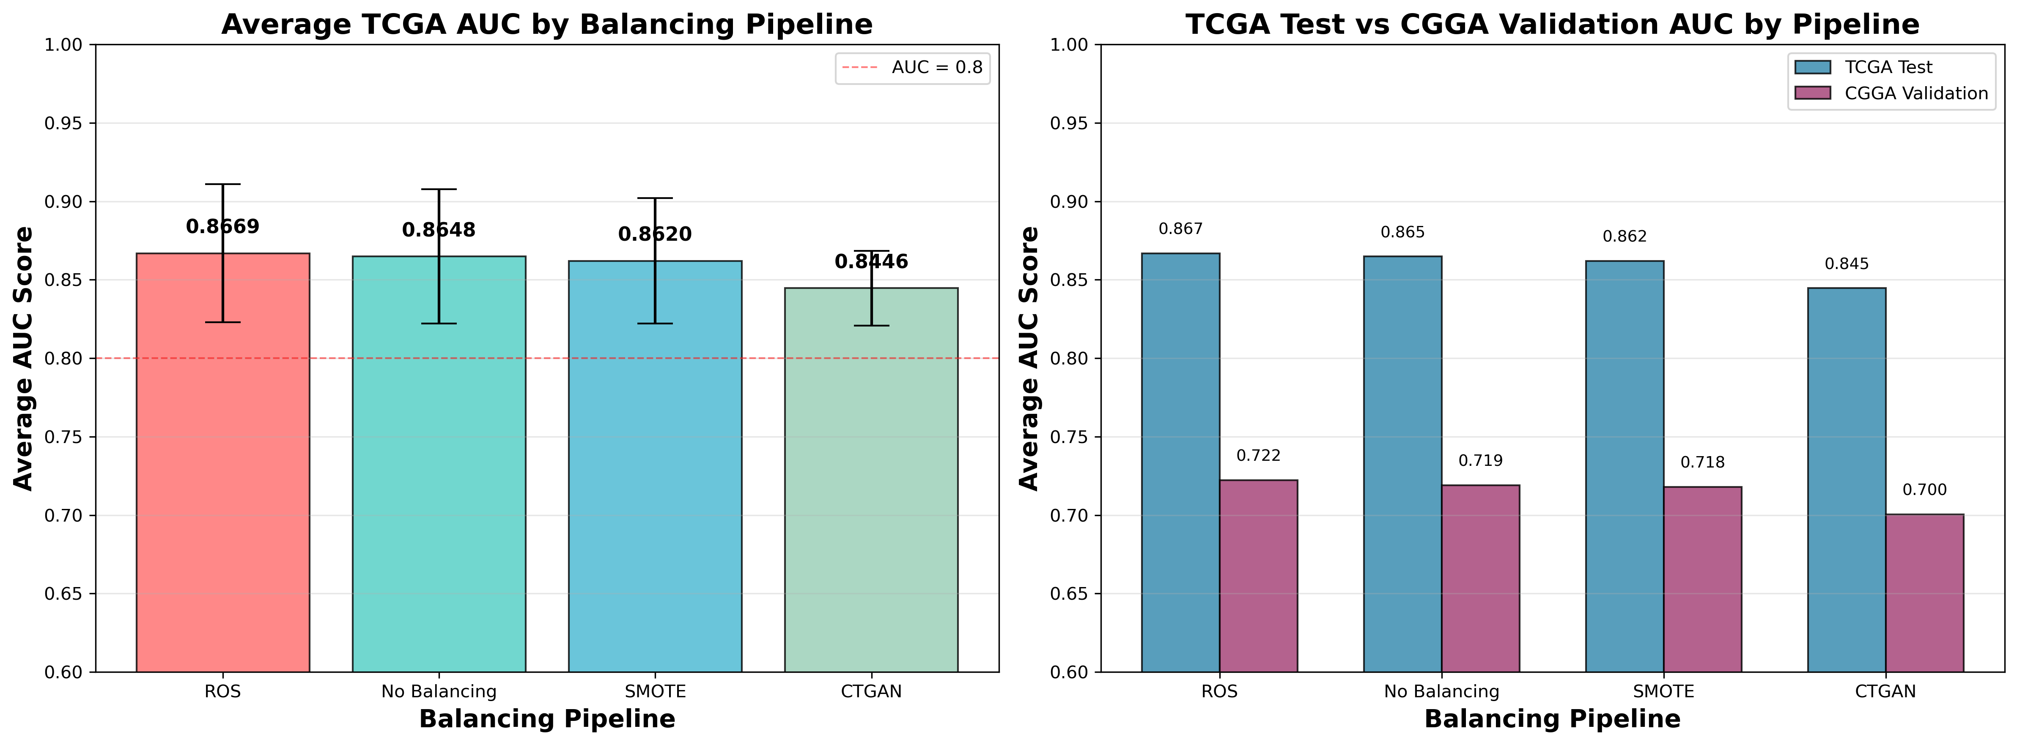

Cross-Cohort Generalization Analysis
External validation on the CGGA cohort reveals differing levels of cross dataset generalization. The top performing model (MOGAT/ROS) experiences and AUC decrease from 0.923 on TCGA to 0.809 on CGGA, representing a generalization gap of 0.114.
This level of performance loss is expected in clinical bioinformatics due to demographic differences, varying sequencing protocols and mutation shifts between the North American(TCGA) and Asian(CGGA) cohorts.
Overall Best Model
MOGAT/ROS is the best model across both datasets.
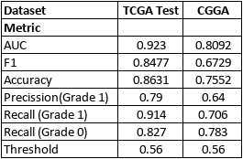
Table 3 - MOGAT in ROS Pipeline

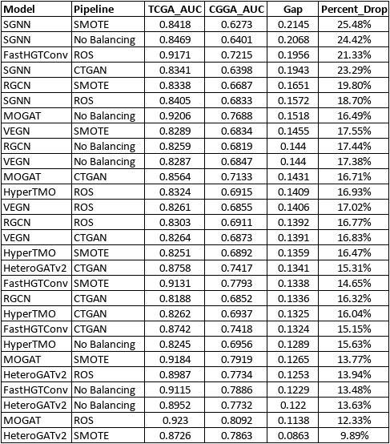
Table 4 - Generalization gap (AUC(TCGA) - AUC(CGGA)) for each model

Clinical Error Analysis(Recall Balance)
From a clinical point of view, the most critical error in glioma grading is a false negative (misclassifying) a high grade tumor as low grade. The MOGAT/ROS model achives a Grade 1 recall of 0.914 while maintaining a Grade 0 recall of 0.827, providing an optimal balance between sensitivity and specificity.
In contrast, several models shows huge class bias. For instance, HyperTMO achieves a Grade 1 recall of 0.986 but only 0.265 for Grade 0, indicating a failure to distinguish classes by simply defaulting to high grade level.
Interpretation: Achieving balanced recall is essential for clinical screening applications to ensure that high risk patients are identified without overwhelming the system with false positives.
